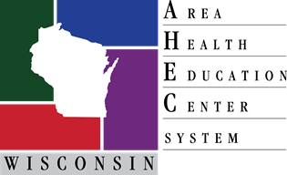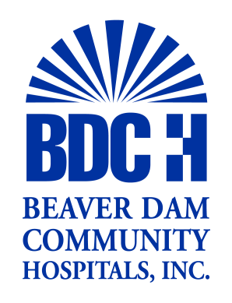

ATTENTION: Sophomores and Juniors
Wednesday November 7, 2018
Beaver Dam Community Hospital
8:30 am - 2:30 pm

HEALTH CAREERS EXPLORATION DAY
OPPORTUNITIES:
- Hospital and Department Tours- Health Works, Medical Imaging & Diagnostics, Surgery, Lab Services
- Health Care Career Information- Human Resources, Health Care Career Ladder, Dietetics, Rehabilitation Services, Blue Zone Project, Moraine Park Technical College
- Hand’s-on Activities and Presentations
- Light Breakfast and Lunch Provided
- Chance to Ask Questions of HC Professionals

REGISTER EARLY to reserve your spot !
- Only $15 per student / Scholarships available
- Required HIPPA/professional training provided
- Applications Available On-line www.scwahec.org (Student Tab / Health Career Exploration Day / Dodge County at bottom)
- Additional Information available in Student Services

Registration Due by October 3rd
Sponsored by: Beaver Dam Community Hospital & South Central WI-AHEC
Questions: Please contact Chris Percy, South Central WI-AHEC
cpercy@scwahec.org (608)219-7629

